Fourier Transform Analysis Report

1. Project Information
Field | Details
Organisation | Darvycom Australia
Project | Darvycom Engineering Laboratory Network and DSP Upgrade
Project stage | Stage II – DSP and Engineering
Unit | ICTTEN826 – Evaluate and apply digital signal processing to communication systems
Network reference | Network 3 – Final Selected Solution
Document ID | C6-FT-01
Version | 1.0
Prepared by | Leonardo Matias Ciarcia – Technical Specialist / Project Manager
Date | 10 March 2026
Location | Darvycom Engineering Laboratory
Document purpose | To document the Fourier transform analysis performed on digital audio signals and explain how the results apply to Darvycom communication systems.

2. Executive Summary
This report documents the Fourier transform analysis completed for the Darvycom Australia Cluster 6 project. It expands the frequency-domain component of the existing DSP Analysis Report and focuses on the conversion of audio signals from the time domain into the frequency domain.
Testing was conducted using the Academo Spectrum Analyzer and Academo Virtual Oscilloscope. Audio Sample 1 and Audio Sample 2 were examined using linear and logarithmic frequency scales. A 300 Hz sine wave was also observed in the time domain to demonstrate the relationship between signal period and frequency.
The results showed that the two audio recordings contained visibly different frequency distributions. The linear frequency scale provided uniform spacing between frequency values, while the logarithmic scale expanded the lower-frequency region and compressed the higher-frequency region. This made speech-related frequencies, harmonics and low-frequency components easier to distinguish.
For the Darvycom MATLAB and DSP simulation model, a sampling frequency of 8,000 samples per second and a 1,024-point Fourier transform were considered. These settings provide a Nyquist frequency of 4,000 Hz and a calculated frequency resolution of 7.8125 Hz.
The analysis supports Darvycom’s IP telephony, video-conferencing and engineering-laboratory requirements by assisting with voice-band verification, interference identification, filter design and comparison of original and processed signals.

3. Purpose and Scope
The purpose of this report is to:
- Explain the Fourier transform and its application to communication signals.
- Compare time-domain and frequency-domain signal representations.
- Examine two audio samples using linear and logarithmic frequency scales.
- Calculate the frequency resolution and Nyquist limit of the Darvycom DSP model.
- Compare expected analytical behaviour with the simulation evidence.
- Explain how Fourier analysis supports the Darvycom communication solution.
- Identify limitations and recommend additional testing evidence.
The report focuses on audio and DSP analysis. Packet Tracer connectivity testing and PRTG network monitoring are supporting activities documented separately in the broader DSP Analysis Report.

4. Fourier Transform Fundamentals

4.1 Time-domain representation
A time-domain representation shows how signal amplitude changes over time. It can be used to observe:
- Signal duration
- Amplitude changes
- Repeating waveform patterns
- Sudden events or transients
- Clipping and distortion
- Periodic behaviour
For example, the Virtual Oscilloscope displayed a repeating 300 Hz sine wave. The expected period of this signal is:
$$T=\frac{1}{f} \\ T=\frac{1}{300}=0.00333\text{ seconds}$$
Therefore, one complete cycle takes approximately 3.33 milliseconds. With the oscilloscope set to 1 millisecond per division, the displayed cycle length was consistent with the expected analytical result.

4.2 Frequency-domain representation
A frequency-domain representation shows the frequencies contained in a signal and their relative strength. It is useful for identifying:
- Dominant frequencies
- Harmonics
- Signal bandwidth
- Electrical or acoustic interference
- Background noise
- Unwanted tones
- Changes produced by digital filtering
A complex audio waveform may be difficult to interpret in the time domain because multiple frequencies are combined. Fourier analysis separates the waveform into its individual frequency components.

4.3 Discrete Fourier Transform
For sampled digital signals, frequency analysis is performed using the Discrete Fourier Transform:
$$X[k]=\sum_{n=0}^{N-1}{x[n]}e^{-j2πkn/N}$$
Where:
- $x[n]$ is the time-domain input sequence.
- $X[k]$ is the frequency-domain result.
- $N$ is the number of samples.
- $n$ is the time-sample index.
- $k$ is the frequency-bin index.
- $∣X[k]∣$ represents the magnitude of each frequency component.
- The angle of $X[k]$ represents the phase.
The Fast Fourier Transform, or FFT, is an efficient algorithm used to calculate the DFT. The FFT produces the same frequency-domain result but requires fewer calculations.

5. Fourier Analysis Parameters
The following parameters apply to the Darvycom MATLAB and DSP simulation model.
Parameter | Value | Interpretation
Sampling frequency, $F_{s}$ | 8,000 Hz | Number of samples recorded per second
Transform length, $N$ | 1,024 samples | Number of samples analysed in one FFT frame
Observation duration | 0.128 seconds | $$N/F_{s}$$
Frequency resolution | 7.8125 Hz | Distance between adjacent FFT bins
Nyquist frequency | 4,000 Hz | Highest frequency represented without aliasing
Nominal voice band | 300–3,400 Hz | Main frequency range used for voice communication
Reference interference | 3,000 Hz | Example interference within the voice-analysis range
Target SNR | At least 20 dB | Darvycom signal-quality target
Maximum network delay | 150 ms | Darvycom real-time communication target

5.1 Frequency-resolution calculation
$$Δf=\frac{F_{s}}{N} \\ Δf=\frac{8000}{1024}=7.8125\text{ Hz}$$
Adjacent FFT bins are separated by 7.8125 Hz.

5.2 Nyquist-frequency calculation
$$f_{\text{Nyquist}}=\frac{F_{s}}{2} \\ f_{\text{Nyquist}}=\frac{8000}{2}=4000\text{ Hz}$$
The selected sampling frequency can represent frequency components up to 4,000 Hz without aliasing. This is suitable for the nominal voice band of 300–3,400 Hz.

5.3 Observation-duration calculation
$$t=\frac{N}{F_{s}} \\ t=\frac{1024}{8000}=0.128\text{ seconds}$$
Each 1,024-sample analysis frame represents 0.128 seconds of the signal.

5.4 Frequency-bin examples
The FFT bin associated with a frequency is calculated using:
$$k=\frac{fN}{F_{s}}$$
For a 3,000 Hz interference component:
$$k=\frac{3000×1024}{8000}=384$$
Therefore, a 3,000 Hz component would appear at FFT bin 384.
The nominal 300–3,400 Hz voice band corresponds approximately to bins 39 to 435.
Important clarification: the 8 kHz sampling rate and 1,024-point transform apply to the Darvycom MATLAB/DSP model. The Academo screenshots use the browser’s audio configuration and display a wider frequency range. They are used as qualitative spectrum evidence rather than proof of the 8 kHz FFT configuration.

6. Tools and Test Inputs
Tool or input | Purpose
Academo Spectrum Analyzer | Displayed the frequency content of Audio Sample 1 and Audio Sample 2
Academo Virtual Oscilloscope | Displayed signal amplitude over time
Audio Sample 1 | First communication-audio input used for spectrum analysis
Audio Sample 2 | Second communication-audio input used for comparison
MATLAB | Supports numerical FFT calculations, plotting, filtering and DSP verification
PRTG Network Monitor | Monitors transport conditions that may affect digital voice and video
Cisco Packet Tracer | Confirms that processed digital information can travel across Network 3

7. Test Procedure
The following procedure was completed:
- Open the Academo Spectrum Analyzer.
- Upload or select Audio Sample 1.
- Allow the recording to play until sufficient spectral information is visible.
- Keep the logarithmic frequency-scale option disabled and capture the linear-scale result.
- Enable the logarithmic frequency-scale option and capture the second result.
- Repeat the same procedure using Audio Sample 2.
- Compare the frequency distribution and intensity patterns of the two recordings.
- Open the Academo Virtual Oscilloscope.
- Select a 300 Hz sine wave and observe it using a 1 ms per division setting.
- Compare the displayed waveform period with the analytical period of approximately 3.33 ms.
- Record the results and retain screenshots as evidence.
To ensure a fair comparison, the same analyser and similar display settings were used for both audio samples.

8. Results and Interpretation

8.1 Audio Sample 1 – Linear Frequency Scale

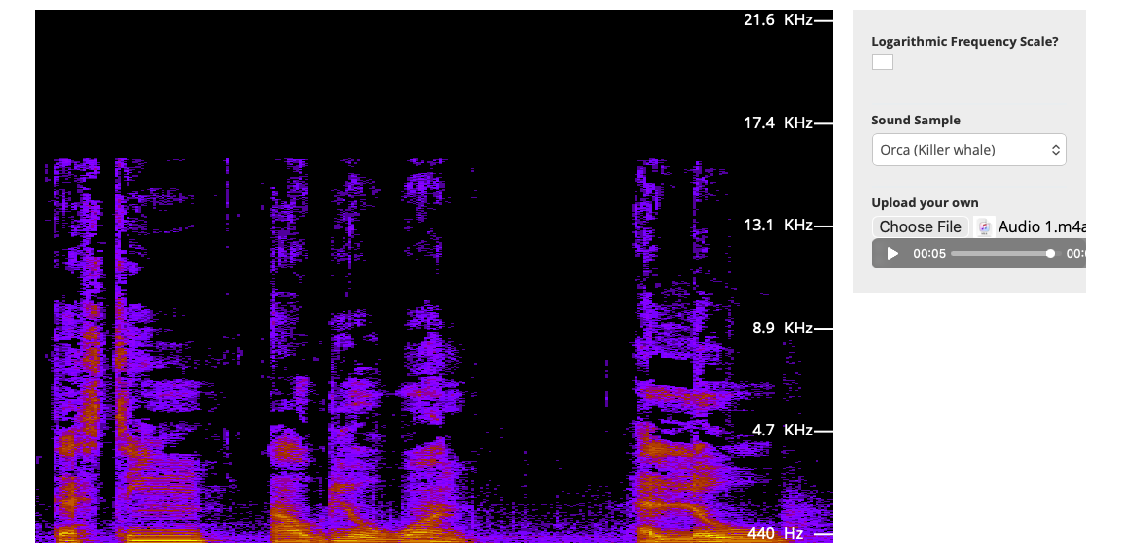
Figure 1. Audio Sample 1 displayed using the linear frequency scale.

The linear frequency scale used equal spacing for equal frequency differences. For example, the visual distance between 1,000 Hz and 2,000 Hz was similar to the distance between 10,000 Hz and 11,000 Hz.
The display made it possible to observe the main frequency regions contained in Audio Sample 1. However, because the full frequency range was distributed evenly, the lower-frequency region occupied a relatively small part of the display.

8.2 Audio Sample 1 – Logarithmic Frequency Scale

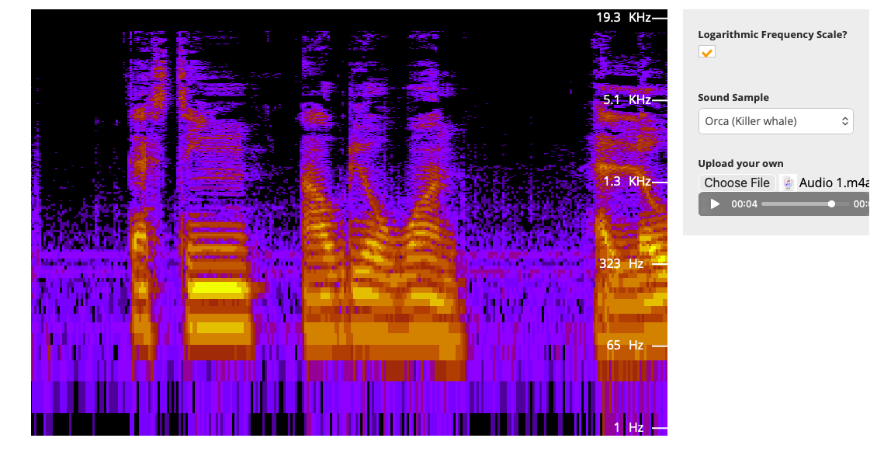
Figure 2. Audio Sample 1 displayed using the logarithmic frequency scale.

The logarithmic frequency scale used equal spacing for equal frequency ratios rather than equal frequency differences. This expanded the lower-frequency portion of the spectrum and compressed the higher-frequency portion.
The logarithmic view made the structure of the low and middle frequencies easier to distinguish. This is useful for voice and audio analysis because many important speech components are located in the lower part of the audible spectrum.
The logarithmic setting changed the frequency-axis presentation. It did not create additional frequencies and did not automatically convert the signal amplitude into decibels.

8.3 Audio Sample 2 – Linear Frequency Scale

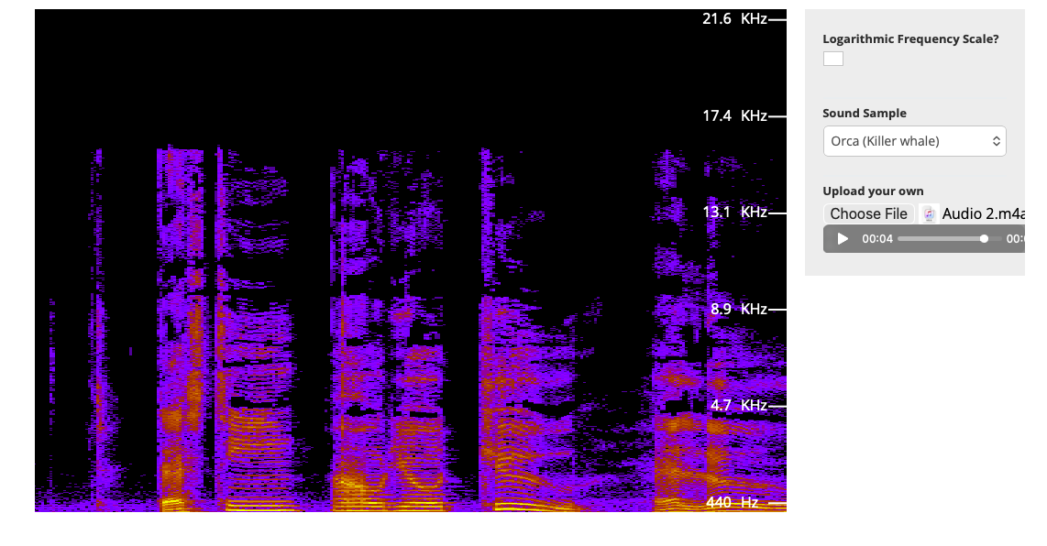
Figure 3. Audio Sample 2 displayed using the linear frequency scale.

Audio Sample 2 produced a visibly different spectral pattern from Audio Sample 1. The timing, distribution and concentration of the frequency components were different, confirming that the two recordings contained different audio information.
The linear display provided a direct overview of the complete measured frequency range.

8.4 Audio Sample 2 – Logarithmic Frequency Scale

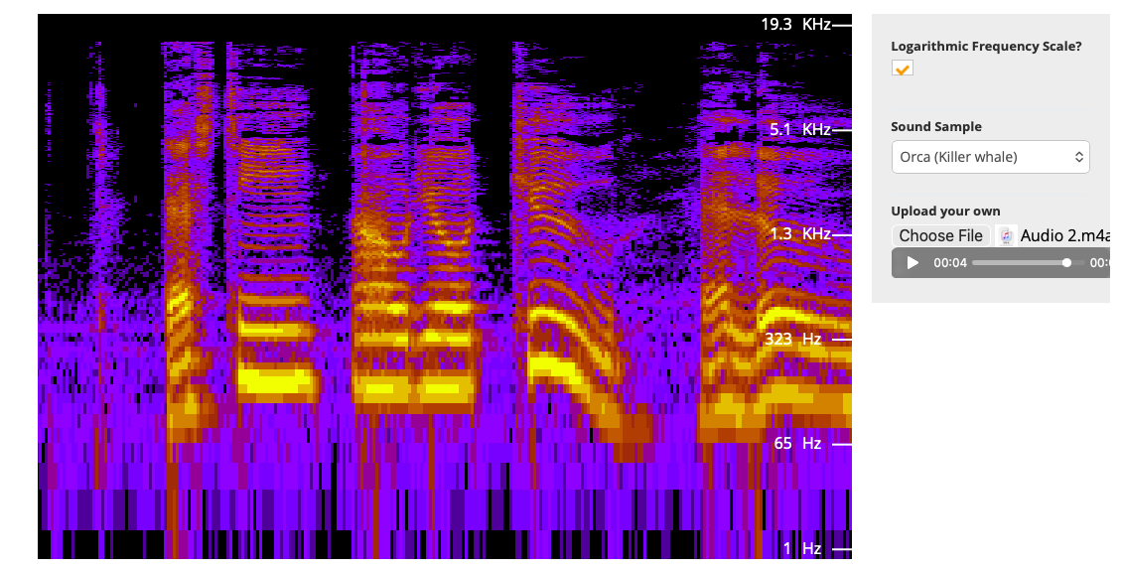
Figure 4. Audio Sample 2 displayed using the logarithmic frequency scale.

The logarithmic view expanded the lower-frequency regions of Audio Sample 2. Harmonic patterns and changes in the low-to-middle frequency range became easier to separate visually.
The result demonstrated that logarithmic frequency scaling can improve the interpretation of voice-related and musical frequency components when the complete audio range is being displayed.

8.5 Time-Domain Oscilloscope Test

The Virtual Oscilloscope displayed a periodic sine wave with the following settings:
Setting | Value
Input signal | Sine wave
Frequency | 300 Hz
Oscilloscope gain | 1.0
Time scale | 1 ms per division
Voltage scale | 5 V per division
The calculated period of a 300 Hz signal was approximately 3.33 ms. The displayed waveform showed approximately one complete cycle every 3.3 time divisions, which was consistent with the expected analytical result.
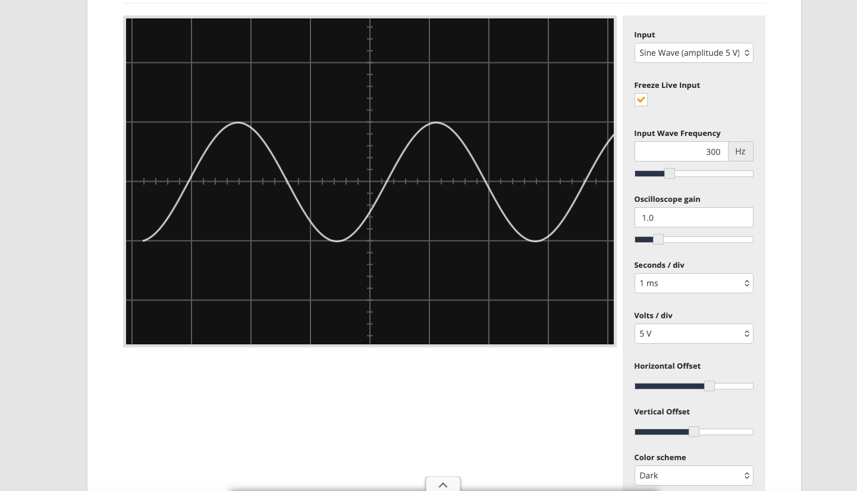
Figure 5. Time-domain waveform used to support the Fourier analysis.

9. Linear and Logarithmic Scale Comparison
Analysis view | Main characteristic | Advantage | Limitation
Linear frequency scale | Equal distance represents equal frequency differences | Provides a direct overview of the complete frequency range | Lower frequencies may be compressed into a small display area
Logarithmic frequency scale | Equal distance represents equal frequency ratios | Expands low frequencies and makes octave relationships easier to observe | High-frequency ranges are visually compressed
Time-domain display | Shows amplitude against time | Useful for duration, transients, periodicity and clipping | Does not directly separate individual frequencies
Frequency-domain display | Shows signal content against frequency | Useful for bandwidth, harmonics, tones, noise and interference | Does not clearly show when a component occurred unless time-frequency analysis is used

10. Analytical and Simulated Result Comparison
Expected analytical behaviour | Observed evidence | Assessment
Fourier analysis separates a complex signal into frequency components | Both audio recordings produced visible frequency distributions | Consistent
Different audio inputs produce different spectra | Audio Sample 1 and Audio Sample 2 displayed different spectral patterns | Consistent
Logarithmic frequency scaling expands low-frequency detail | Low-frequency components occupied more display space after enabling the logarithmic option | Consistent
A 300 Hz signal has a period of approximately 3.33 ms | The oscilloscope displayed approximately one cycle every 3.3 divisions at 1 ms/division | Consistent
An 8 kHz sampling rate provides a 4 kHz Nyquist limit | Confirmed through calculation | Consistent by calculation
A 1,024-point FFT at 8 kHz provides 7.8125 Hz resolution | Confirmed using $F_{s}/N$ | Consistent by calculation

11. Application to Darvycom Communication Systems

11.1 IP telephony
Fourier analysis can be used to confirm whether speech energy is mainly contained within the expected 300–3,400 Hz voice band. It can also identify unwanted tones, microphone noise, electrical interference or missing frequency components that may reduce voice clarity.

11.2 Interference identification
An unwanted narrowband signal would appear as a concentrated frequency component. Under the Darvycom simulation settings, the known 3,000 Hz interference component would appear at FFT bin 384.
After identifying the interference, Darvycom could apply an appropriate digital filter and compare the spectrum before and after processing.

11.3 Video-conferencing audio
Spectrum analysis can help determine whether poor video-conferencing audio originates from microphones, background noise or signal-processing problems.
Network faults must be investigated separately. Packet loss, latency, jitter and congestion should be checked using Packet Tracer, PRTG or other network-monitoring tools.

11.4 Engineering laboratory
The Darvycom engineering laboratory can use Fourier analysis to:
- Compare original and filtered audio.
- Analyse voice and communication signals.
- Detect harmonics and interference.
- Evaluate digital filters.
- Analyse modulation experiments.
- Verify DSP algorithms.
- Compare analytical and simulated results.

11.5 Network relationship
Network provides the communication platform needed to transport digital voice, video and data between IP phones, servers, video-conferencing equipment and engineering computers.
Fourier analysis evaluates the signal at the endpoint, while VLANs, QoS, routing and PRTG monitoring support reliable transportation of the processed digital information.
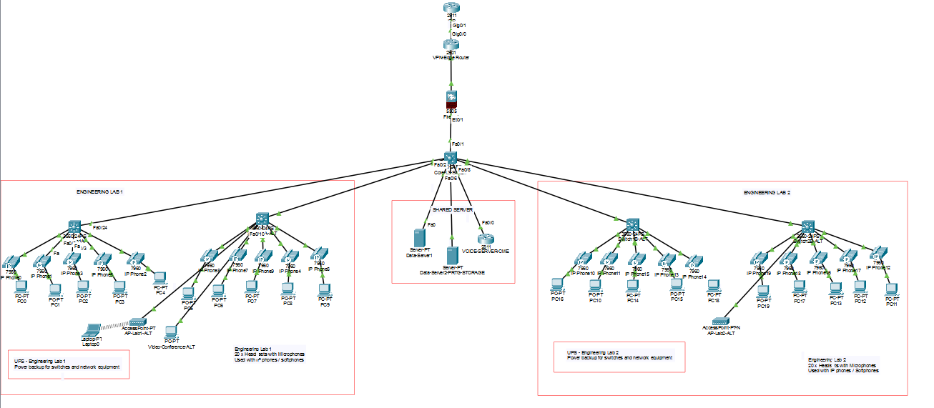

12. Problems, Limitations and Corrective Actions
Problem or limitation | Impact | Corrective action
Linear scale provided limited space for lower frequencies | Some low-frequency details were difficult to separate | The logarithmic frequency scale was enabled
Screenshots did not provide exported numerical data | Exact amplitude and peak-frequency values could not be confirmed | Use MATLAB or an analyser export for quantitative measurements
Browser analyser showed a wider frequency range than the 8 kHz project model | Screenshot range could be confused with the project’s Nyquist limit | Clearly separate browser-based qualitative evidence from MATLAB calculations
Spectrum images were not calibrated for absolute magnitude | Exact SNR and noise-floor values could not be calculated | Conduct a separate calibrated SNR test
Network performance cannot be determined from a Fourier spectrum | Packet loss or latency could be incorrectly treated as a DSP problem | Use PRTG and Packet Tracer for transport-network measurements
FFT calculations may be affected by spectral leakage | Energy may spread into adjacent FFT bins | Apply a Hann or similar window before the FFT

13. Findings
The Fourier transform analysis produced the following findings:
- Both audio samples were successfully represented in the frequency domain.
- Audio Sample 1 and Audio Sample 2 contained different spectral characteristics.
- The linear frequency scale provided a direct view of the complete frequency range.
- The logarithmic frequency scale expanded the lower-frequency area and improved the visual separation of speech-related components.
- The 300 Hz oscilloscope waveform was consistent with the expected period of approximately 3.33 ms.
- The 8 kHz Darvycom DSP model is suitable for the nominal 300–3,400 Hz voice band.
- The 1,024-point transform provides a calculated frequency resolution of 7.8125 Hz.
- The screenshots support qualitative interpretation but do not provide calibrated amplitude, SNR or exact peak-frequency measurements.

14. Recommendations
- Retain the original Audio Sample 1 and Audio Sample 2 files with the screenshots.
- Use the same sampling rate, FFT length and window when comparing original and filtered signals.
- Complete a MATLAB FFT test and export the numerical frequency and magnitude results.
- Record the exact dominant frequencies for both audio samples.
- Apply a Hann window when spectral leakage affects the FFT result.
- Measure SNR separately and confirm that the Darvycom target of at least 20 dB is achieved.
- Compare spectra before and after applying the selected digital filter.
- Continue using PRTG to monitor packet loss, latency, utilisation and congestion separately from the DSP analysis.

15. Conclusion
The Fourier transform analysis was completed for the Darvycom Australia Cluster 6 DSP solution using two audio samples and a time-domain oscilloscope test. The results demonstrated how digital audio can be examined in the frequency domain and how linear and logarithmic frequency scales provide different views of the same signal.
The linear scale displayed equal frequency differences using equal spacing, while the logarithmic scale expanded the lower-frequency region and compressed the higher-frequency region. This made the logarithmic view particularly useful for examining speech-related components and harmonic relationships.
The 300 Hz oscilloscope test produced a waveform period consistent with the calculated result of approximately 3.33 ms. The Darvycom MATLAB model calculations also confirmed a 4,000 Hz Nyquist limit and 7.8125 Hz frequency resolution when using an 8 kHz sampling frequency and a 1,024-point transform.
Based on the available evidence, Fourier analysis is suitable for supporting Darvycom IP telephony, video-conferencing audio and engineering-laboratory DSP activities. Further MATLAB testing is recommended when exact frequency, magnitude and SNR measurements are required.

